Birds Classification based on Bird Sound

by
Girish Lumdeo Rane MIS No 121997014

Guide
Prof Priti P. Rege

Dissertation submitted to the Faculty of the Engineering of the Savitribai Phule University of Pune, in partial fulfillment
of the requirements for the degree of Masters in Electronics and Telecommunications
Year


Department of Electronics and Telecommunication Engineering College of Engineering, Pune
2021



Department of Electronics and Telecommunication Engineering College of Engineering, Pune

CERTIFICATE

This is to certify that the thesis titled ”Birds Classification based on Bird Sound” submitted by Girish Lumdeo Rane (121997014) in partial fulfillment of the requirements for the award of Master of Technology degree in Electronics and Telecommunication Engineering, with specialization in Signal Processing during year 2020-21 at College of Engineering, Pune is an authenticate work by her under my supervision and guidance.

Certified by

Prof. Priti P. Rege Dr S.P.Mahajan
Project Guide Head of Department

Date:
Place: COEP,Pune

Dissertation Approval

This dissertation entitled

Birds Classification based on Bird Sound

by
Girish Lumdeo Rane

is approved for the degree of

Master of Technology with Specialization in Signal Processing

of
Electronics and Telecommunication Department College of Engineering Pune
(An Autonomous Institute of Govt. of Maharashtra)

Examiners | Name | Signature
1. External Examiner
2. Guide/Supervisor

Declaration

I declare that this written submission represents my ideas in my own words and where others’ ideas or words have been included, I have adequately cited and ref- erenced the original sources. I also declare that I have adhered to all principles of academic honesty and integrity and have not misrepresented or fabricated or falsi- fied any idea/data/fact/source in my submission. I understand that any violation of the above will be cause for disciplinary action by the Institute and can also evoke penal action from the sources which have thus not been properly cited or from whom proper permission has not been taken when needed.

Girish Lumdeo Rane (121997014)

Date:

Place:

Acknowledgment

I would like to express my heartfelt gratitude to my project guide and supervisor, Prof. Priti.P. Rege for her valuable inputs and timely suggestions. I thank her for allowing me to lead my project work with entire freedom which allowed me to unfold new and affective aspects in my werk Her priceless experience and ability to lead towards perfection helped me accomplish the work with total contentment.
I would like to thank my parents for always motivating me and believing in me. I am also thankful to my seniors, colleagues, and lab assistants for their support and inspiration.
The Mtech project experience with above all have indulged in me important values and principles which are going to help me throughout my life.

(Girish Lumdeo Rane)

ABSTRACT

Automatic classification of bird calls plays an essential role in monitoring and pro- tecting biodiversity. Classifying bird species is a challenging problem due to variant species present in the world. This work is focused on identifying different bird species. This project deals with various feature extraction techniques to classify species of birds. Also, feature selection is carried out to reduce the complexity and increase the accuracy of classifiers. The MFCCs, LFCCs and GFCCs have been extracted directly from birds recording. Also, the methodology is tested on four dif- ferent classifiers viz K-Nearest Neighbors (KNN), Support Vector Machine (SVM), Artificial neural networks (ANNs) and Convolutional Neural Network(CNN).

Table of Contents

List of Tables xiii
List of Figures xv
List of Abbreviations xvii
- Introduction 1
  - Motivation 1

1.2 Objectives . . . . . . . . . . . . . . . . . . . . . . . . . . . . . . . . | .1
1.3 Organization of Thesis . . . . . . . . . . . . . . . . . . . . . . . . . | .2
1.4 Summary . . . . . . . . . . . . . . . . . . . . . . . . . . . . . . . . | .2
2 Literature Review  2.1 Introduction . . . . . . . . . . . . . . . . . . . . . . . . . . . . . . . | .3 | 3
2.2 Birds Classification using various methods . . . . . . . . . . . . . . | .3
2.3 Birds Classification using classifier . . . . . . . . . . . . . . . . . . . | .4
2.4 Summary . . . . . . . . . . . . . . . . . . . . . . . . . . . . . . . . | .5
3 Feature Extraction and Selection |  | 7
3.1 Introduction . . . . . . . . . . . . . . . . . . . . . . . . . . . . . . . | .7
3.2 Mel Frequency Cepstral Coefficients . . . . . . . . . . . . . . . . . . | .7
3.3 Linear Frequency Cepstral Coefficient . . . . . . . . . . . . . . . . . | .9
3.4 Gammatone Frequency Cepstral Coefficient . . . . . . . . . . . . . | .9
3.5 Feature Selection . . . . . . . . . . . . . . . . . . . . . . . . . . . . | .11

    - Filter Method 12
    - Wrapper Method 12
    - Embedded Method 13
3.6 Summary 14
- Classification 15
  - Introduction 15
  - K-Nearest Neighbor 15
  - Support Vector Machine 16
  - Artificial Neural Network 16
  - Convolutional Neural Network 17
  - Summary 18
- Experimental Data and Results 19
  - Introduction 19
  - Experimental setup 19
  - Data Description 19
  - Result 19
  - Result for Feature Extraction 20
    - Result for MFCC 20
    - Result for LFCC 22
    - Result for GFCC 24
  - Selection of Optimum parameters 26
    - Result for MFCC 28
    - Result of LFCC 29
    - Result of GFCC 30
  - Classification 31
    - Classification using KNN 31
      - Result of MFCC 31
      - Result of LFCC 33
      - Result of GFCC 35
    - Classification using ANN 37
      - Result of MFCC 37
      - Result of LFCC 39
      - Result of GFCC 41
    - Classification using CNN Algorithm 43
      - Result of MFCC 43
      - Result of LFCC 45
      - Result of GFCC 47
  - Summary 50
- Conclusion and Future Scope 51
Bibliography 53
Bibliography 55

List of Tables

  - Description of Bird Species Dataset 20
  - Recognition of result with MFCC (13) features 21
  - Recognition of result with MFCC (26) features 21
  - Recognition of result with MFCC (39) features 22
  - Recognition of result with LFCC (13) features 22
  - Recognition of result with LFCC (26) features 23
  - Recognition of result with LFCC (39) features 23
  - Recognition of result with GFCC (13) features 24
  - Recognition of result with GFCC (26) features 24
  - Recognition of result with GFCC (39) features 25
  - Overall Accuracy of Feature Extraction 25
  - Feature Selection 27
  - Recognition of result with MFCC (27) features 28
  - Recognition of result with MFCC (27) features with KNN algorithm .28
  - Recognition of result with LFCC (27) features 29
  - Recognition of result with LFCC (27) features with KNN algorithm .29
  - Recognition of result with GFCC (27) features 30
  - Recognition of result with GFCC (27) features with KNN algorithm .30
  - Overall Accuracy of Feature Selection 31
  - Recognition of result with MFCC (13) features with KNN algorithm .31
  - Recognition of result with MFCC (26) features with KNN algorithm .32
  - Recognition of result with MFCC (39) features with KNN algorithm .32

  - Recognition of result with LFCC (13) features with KNN algorithm .33
  - Recognition of result with LFCC (26) features with KNN algorithm .33
  - Recognition of result with LFCC (39) features with KNN algorithm .34
  - Recognition of result with GFCC (13) features with KNN algorithm .35
  - Recognition of result with GFCC (26) features with KNN algorithm .35
  - Recognition of result with GFCC (39) features with KNN algorithm .36
  - Overall Accuracy of Feature Extraction using KNN algorithm 36
  - Overall Accuracy of Feature Extraction using ANN algorithm 43
  - Overall Accuracy of Feature Extraction using CNN algorithm 49
  - Classification accuracy of Different Feature set and classifiers 49

List of Figures

  - Overview of steps involved in the extraction of MFCCs 8
  - Mel Filter Bank 9
  - Overview of steps involved in the extraction of LFCCs 10
  - Overview of steps involved in the extraction of GFCCs 10
  - Block Diagram of Feature selection methods 11
  - Block diagram of the filter method 12
  - Wrapper method for feature selection 13
  - Embedded method for feature selection 13
  - Example of KNN classifiers 16
  - Block Diagram of ANN Model 17
  - Block Diagram of CNN Architecture 18
  - Accuracy vs number of features selected 27
  - Training and Validation Accuracy and loss of 13 MFCC coefficients .37
  - Training and Validation Accuracy and loss of 26 MFCC coefficients .37
  - Training and Validation Accuracy and loss of 39 MFCC coefficients .38
  - Training and Validation Accuracy and loss of 27 MFCC coefficients .38
  - Training and Validation Accuracy and loss of 13 LFCC coefficients 39
  - Training and Validation Accuracy and loss of 26 LFCC coefficients 39
  - Training and Validation Accuracy and loss of 39 LFCC coefficients 40
  - Training and Validation Accuracy and loss of 27 LFCC coefficients 40
  - Training and Validation Accuracy and loss of 13 GFCC coefficients .41

  - Training and Validation Accuracy and loss of 26 GFCC coefficients .41
  - Training and Validation Accuracy and loss of 39 GFCC coefficients .42
  - Training and Validation Accuracy and loss of 27 GFCC coefficients .42
  - Training and Validation Accuracy and loss of 13 MFCC coefficients .43
  - Training and Validation Accuracy and loss of 26 MFCC coefficients .44
  - Training and Validation Accuracy and loss of 39 MFCC coefficients .44
  - Training and Validation Accuracy and loss of 27 MFCC coefficients .44
  - Training and Validation Accuracy and loss of 13 LFCC coefficients . .45
  - Training and Validation Accuracy and loss of 26 LFCC coefficients . .45
  - Training and Validation Accuracy and loss of 39 LFCC coefficients . .46
  - Training and Validation Accuracy and loss of 27 LFCC coefficients . .46
  - Training and Validation Accuracy and loss of 13 GFCC coefficients .47
  - Training and Validation Accuracy and loss of 26 GFCC coefficients .47
  - Training and Validation Accuracy and loss of 39 GFCC coefficients .48
  - Training and Validation Accuracy and loss of 27 GFCC coefficients .48

List of Abbreviations

FC Fully Connected
DCT Discrete Cosine Transform KNN k-Nearest Neighbors
STFT Short Time Fourier Transform MFCC Mel Frequency Cepstral Coefficient LFCC Linear Frequency Cepstral Coefficient
GFCC Gammatone Frequency Cepstral Coefficient SVM Support Vector Machine
ANN Artificial Neural Network CNN Convolutional Neural Network

Chapter 1 Introduction

Motivation
Last few decades, lots of research is carried out in the analysis of bird audio signals. Birds are good indicators of the health of the environment. They play a significant role in the ecosystem. Identification of bird species can be made through image, video and audio. Audio processing is widely used for capturing species. The great- est challenge is identifying bird species of interest within large recordings. Therefore, the auto- matic approach is used for the classification of species. Various techniques are used to identify acoustic, such as Mel Frequency Cepstral Coefficients (MFCCs), Linear Frequency Cepstral Coefficients (LFCCs), which summarize spectral infor- mation. This project focused on the identification of bird species from their sound. Each bird has a different tone and pitch. The aim is to identify each bird by its sound by removing environmental noise. The deep learning approach is used for the classification of species into different categories.

Objectives
- To create a dataset of bird sound.
- To study and Extract features from bird sound.
- To select optimum feature for bird classification.
- To perform classification of bird species using different machine learning algo- rithms.
- To compare the performance of various classification algorithms.

Organization of Thesis
Chapter 1 provides an introduction to the project.
Chapter 2 gives the literature survey of various approaches.
Chapter 3 presents different Feature Extraction and Selection Techniques. Chapter 4 explain different classification methods.
Chapter 5 discuss experimental data and result of classifiers Chapter 6 provides the conclusion and future scope.

Summary
This chapter introduces the fundamental idea of this thesis. It gives the motiva- tion behind automatic bird classification. It covered a preview of how the thesis is planned and gives the whole concept of the project.

Chapter 2 Literature Review

Introduction
The deep learning model has recently attracted a lot of attention due to its high performance in building automatic bird sound classification systems. Support Vector Machine(SVM), k-nearest neighbour (KNN), Artificial Neural Network(ANN) are used as classifiers. Literature of various approaches that are widely used in audio classification is explored for the recognition of bird sounds.

Birds Classification using various methods
Charisma, M. R. Hidayat and Y. B. Zainal, showed the use of Mel Frequency Cep- stral Coefficients with Vector Quantization for speaker verification. VQ is used to produce a vector of each speech signal. Vector quantization creates a cluster of each vector area called codebook.

P. Jancovic, M. K fi ok¨ uer, M. Zakeri, and M. Russell suggested tonal-based fea- tures to identify tonal bird sounds. The Gaussian mixture model is used to model 95 bird species. Each bird sound contains white noise and environmental noise.The Tonal-based approach provides better performance compared to Mel Frequency Cep- stral Coefficients.

Lee, Chang-Hsing Lee, Yeuan-kuen Huang, Ren-zhuang suggested a new method to identify species. First, average MFCC and average LPCC are calculated to create a feature vector. Then, linear discriminant analysis is used to increase the accuracy

of the feature vector.

Trifa VM, Kirschel AN, Taylor CE, Vallejo EE have used the Hidden Markov Model for acoustic bird classification. The work uses five bird species without noisy record- ing.

Dewi, Sita & Prasasti, Anggunmeka & Irawan, Budhi designed a new feature extrac- tion technique called Linear Frequency Cepstral Coefficients (LFCC). LFCC uses a Linear Filter bank K-nearest neighbour algorithm is implemented to detect baby is crying or not.

Birds Classification using classifier
J. Xie, K. Hu, M. Zhu, J. Yu and Q. Zhu, proposed different types of time-frequency representations called Mel, harmonic and percussive spectrogram. CNN fused model gives balanced accuracy of 86.31 %.

A´. Incze, H. Jancs´o, Z. Szil´agyi, A. Farkas and C. Sulyok, , have developed a method- ology to classify species using spectrogram. A pre-trained MobileNet CNN model was used to differentiate species. STFT of each audio file given to input to CNN model. This experiment shows the colour map of the spectrogram gives more ad- vantages than a normal spectrogram.

Patole R., Rege P. suggested identifying birds by their sounds using Mel Frequency Cepstral Coefficients (MFCC) and Gammatone Frequency Cepstral Coefficients (GFCC) for classification. The feature set is evaluated using the Support Vector Machine and Artificial Neural Network.

Summary
In this chapter, literature related to birds classification is explored. Birds classifi- cation can be done in the traditional method and deep learning approach. Various features used by earlier researchers is also discussed

Chapter 3
Feature Extraction and Selection

Introduction
In this Chapter, Different feature extraction techniques are discussed. This tech- nique extract features from the audio signal. Also, a procedure for the best feature selection is demonstrated. Each method discusses the steps of deriving a feature vector from bird sound.

Mel Frequency Cepstral Coefficients
Mel frequency cepstral coefficients have been used for speaker recognition. Speaker recognition is mainly divided into two parts, identification and verification. For verification, the goal is to verify the speaker. For identification, the goal is to de- termine which group matches the voice of the sample species. Feature extraction is the extraction of small information from voice data that represent the speaker. This information is stored in vector form and used for the classification of bird species.

The MFCCs are used in the feature extraction process. The block diagram of MFCC is shown in Figure 3.1,

The first step is Pre-Emphasis. Pre-emphasis refers to filtering that emphasizes the higher frequencies. Framing Each bird signal has framed the block with overlapping. The framing process divides the whole audio signal into small frames. The Hamming window is applied to each frame. Fast Fourier Transform converts small frame signal

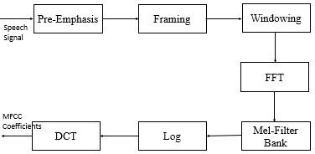

Figure 3.1: Overview of steps involved in the extraction of MFCCs

to the frequency domain. The equation to convert the normal frequency to Mel frequency is given by,

M el(f ) = 2595 ∗ log( 700 ) (3.1)
f

The calculated power spectrum is mapped with Mel frequency with the help of a filter bank. The filter bank is narrow in the lower frequency range and wider in the higher frequency range. The equation of triangular filter bank given as,
0, f(m− 1) > k
 k−f (m−1) , f (m− 1) ≥ k <f(m)

H (k) = f (m+1)−f (m)
m
f (m+1) k f (m+1)−f (m)
 − , f (m) ≤ k ≤f(m+1)
0, f(m + 1) < k
(3.2)

Where f() is the list of M +2 mel-spaced frequencies and M is the required number of filters. The design filter bank is applied on each power spectrum.The logarithm of

all these summed values has been obtained and is referred to as a log mel spectrum. Discrete Cosine Transform of log scale spectrogram is MFCC coefficients.
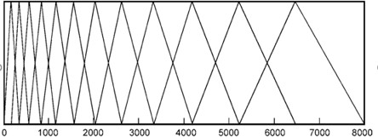

Figure 3.2: Mel Filter Bank

Linear Frequency Cepstral Coefficient
LFCC uses a Linear frequency scale. The idea behind Linear frequency is a linearly designed frequency band. The difference between the two filter banks is the same. Each filter bank is equally divided. The resolution of frequency in the Mel filter bank decreases for a higher frequency, but in linear frequency, The resolution of the filter bank is the same. A total of 32 filter banks were used. The block diagram of Linear Frequency Cepstral Coefficients is shown in Figure 3.3.

Gammatone Frequency Cepstral Coefficient
The Gammatone Frequency Cepstral Coefficients (GFCC) are auditory character- istics based on a set of Gammatone filters. The gammatone filters are designed to simulate the process of the human auditory system. The equation of centre frequency fc is given by,

g(t) = at^{n−1}e^{2πbt} cos(2πf_{c}t + φ) (3.3)
Where φ is the phase of the filter. Usually, it is set to zero. The constant values a and n defines the order of the filter. The value of a must be less than 4.

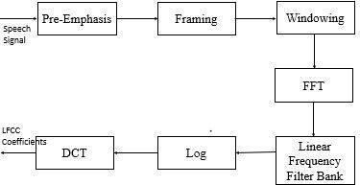

Figure 3.3: Overview of steps involved in the extraction of LFCCs The factor value b is given as,
b = 25.17 ∗ ( 4.37fc + 1) (3.4)
1000

The block diagram of Gammatone Frequency Cepstral Coefficients is shown in figure 3.4,
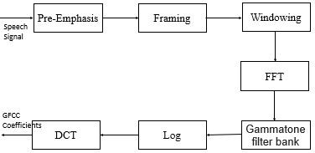

Figure 3.4: Overview of steps involved in the extraction of GFCCs

Feature Selection
Feature selection is a crucial optimization algorithm for classification. Feature se- lection selects only the relevant features and discards all irrelevant and noisy fea- ture.Thus, it is an unrestrained target algorithm. It improves the efficiency and accuracy of the model. The advantages of this approach is to select a small set of features that perform well in an algorithm. The benefits of feature selection are that the learning algorithm only focuses on essential data and a more accurate model without a noisy feature.
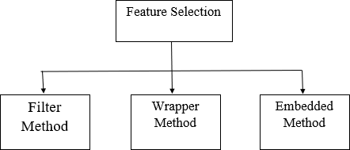

Figure 3.5: Block Diagram of Feature selection methods

The Feature selection algorithm divided into three methods called Filter method, Wrapper method and Embedded method. Filter method uses to evaluate a subset of feature and wrapper method provide the best subset of features. Figure 3.5 shows the block diagram of different feature selection method.I have used wrapper method for feature selection. most commonly used technique under wrapper method are Forward selection,Backward elimination,Bi-directional elimination and I have selected Recursive Feature Elimination(RFE) algorithm.

Filter Method
It is a rarely used method for feature selection. It filters out data from the character- istics of features. The main advantage of the filter method is it is computationally more accessible than the wrapper method. It assigns the ranking and subset of features from a set of all features. Here, The selection of features is independent of classifiers. It is a high correlation with target variables and a low correlation with another independent variable. In this method, features are selected based on four primary subset generation techniques viz., heuristic feature subset selection, forward selection, backward elimination, and bidirectional selection.

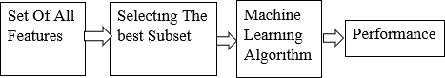

Figure 3.6: Block diagram of the filter method

Wrapper Method
The wrapper method is a greedy search algorithm that finds the minimum number of features by recursive approach. It also selects features based on the performance of classifiers. It starts with an empty set of features, then pools feature from all feature collections and evaluate performance in the algorithm. This process is done recur- sively. It is also called recursive feature selection. Examples of wrapper methods are Recursive feature elimination, genetic algorithm, and sequential feature selection algorithms. Figure 3.7 shows Block Diagram of Wrapper method.
The most commonly used feature selection is Recursive Feature Elimination(RFE). RFE generally removes the least important features and retains the remaining fea- ture. The method for feature selection is used in this work. The most commonly used technique under wrapper method are Forward selection,Backward elimination,

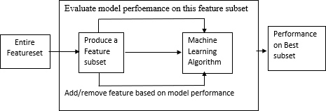

Figure 3.7: Wrapper method for feature selection

Bi-directional elimination. Recursive Feature Elimination(RFE) algorithm is ex- plored in the work.

Embedded Method
The embedded method is the combination of both filter and wrapper methods. The advantage of this algorithm is more accurate and own variable selection to perform classification. This algorithm split all features into all possible ways and selects the best set of features. The most common example is Random Forest Feature Selection. The Block Diagram of the Embedded method is shown in Figure 3.8.
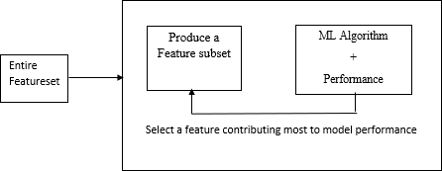

Figure 3.8: Embedded method for feature selection

Summary
In this chapter, we discuss different types of Feature extraction and Feature se- lection techniques. These techniques are helpful for analyzing audio signals. The most commonly used technique is MFCC, i.e., Mel Frequency Cepstral Coefficients. Another two techniques are also beneficial for the application of bird species clas- sification.The computational complexity of the wrapper method is more than the filter and embedded method. Recursive Feature Elimination (RFE) algorithm select features recursively.

Chapter 4 Classification

Introduction
For classification, Each audio signal is represented as a feature vector. This feature vector represents the input to the classifier. K-nearest neighbors classifier is a su- pervised machine learning algorithm along with a Support vector machine (SVM). Artificial Neural Network (ANN) and Convolutional Neural Network (CNN) are also discussed.

K-Nearest Neighbor
It is a supervised machine learning algorithm used for regression and classification. The classification is carried out by a simple majority vote of the nearest neighbor of each query point. For each query point, the value of k is defined by the user. Each query point considers the closest k value and predicts the maximum possible class. The advantage of this algorithm is straightforward and gives promising results. It is also used for identifying similar objects. For this algorithm, there is no need to build the model or set the parameter. For each bird audio signal, the mean value of the feature is extracted to form a vector. This vector acts as input to the KNN algorithm. From experiment data, k=3 gives better accuracy than other k value.
From Figure 4.1, The test sample is either class blue or class red. For the value of k is 3, then the three nearest samples are considered and if the value of k is 5 then the five closest samples are considered.

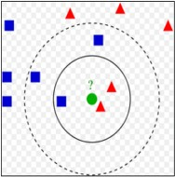

Figure 4.1: Example of KNN classifiers

Support Vector Machine
Support Vector Machine is a supervised machine learning algorithm used for clas- sification and regression problems. The main goal of the support vector machine is to find a hyperplane between two classes. For linear and non-linear problems, support vector machines play an important role. To separate two different classes, the margin between two classes is maximum. Here, the mean value of each feature vector is calculated. This mean value gives input to the support vector machine. Then, the support vector machine calculates the marginal distance between the two classes. For classification, the linear kernel provides the highest accuracy.

Artificial Neural Network
An Artificial Neural Network is a Neural network designed the way the human brain simulates. ANN also consists of neurons that arrange in layers. Generally, ANN contains three layers called the Input layer, hidden layer and output layer. The hidden layer has more than one layer. Each layer has two or more neurons. The ANN uses a training algorithm that learns and updates weights by the backpropagation algorithm. The ReLU (Rectified Linear Unit) activation function assigns value zero if the negative and same value is positive. The block diagram of the ANN algorithm

is shown in fig 4.2
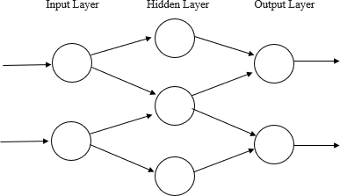

Figure 4.2: Block Diagram of ANN Model

Convolutional Neural Network
CNN is a type of machine learning algorithm where we provide enough input vari- ables in the form of training, so that network can learn itself based on training input and gives accurate output. The layers of CNN contain the Input layer, a hid- den layer and an output layer. It also includes multiple convolution layers, pooling layers. Figure 4.3 shows a block diagram of CNN Architecture.
The convolution network is a 2-D convolution layer. The CNN architecture is divided into two parts, Feature extraction and classification. In Feature extraction, 2-D input is convolved with filters and learns new features. These filters are called “weighted filters” . The max-pooling layer is used to reduce the size of convolution layers. Average pooling is also called Noise Suppressant. For the activation Function, ReLU (Rectified Linear Unit) performs the threshold operation. If the value of the weight filter is less than zero is set to zero. The experiment was performed on different learning rates and chose 0.01.

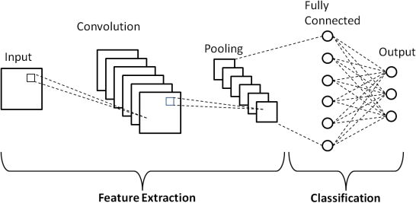

Figure 4.3: Block Diagram of CNN Architecture

The flatten layer converts all filter layers to the 1-D array. It is also called the Fully Connected layer. Each perceptron of layer learn feature and update weights. Finally, the softmax layer is used to calculate the probability of each species.

Summary
In this section, We have discussed different types of classification algorithms. For example, a deep learning approach called the CNN model contains two convolution layers and two flatten layers.

Chapter 5 Experimental Data and Results

Introduction
This section includes all the results achieved by using different feature extraction methods with various classifiers.The experiment is performed to test the perfor- mance of MFCC, LFCC and GFCC feature vector. The feature selection method with 27 coefficients. Each feature vector train and tested with k Nearest Neigh- bour (KNN), Artificial Neural Network (ANN), Support Vector Machine(SVM) and Convolutional Neural Network(CNN).

Experimental setup
Each classifier has been executed using python 3 and Jupyter Notebooks IDE. The machine for execution has a 2.6 GHz Core i5 processor with 4 GB RAM.

Data Description
Table 6.1 shows the list of bird files and scientific names used in this paper. There are 2358 individual files from 10 species. Each audio file is split into a 3-second chunk file. The spectral subtraction algorithm is used to reduce the noise in each chunk.

Result
This section discusses the result of all feature vectors of MFCC, LFCC and GFCC. The experiment has performed on 13,26 and 39 coefficients. In the confusion matrix, the best result is shown in Green color and the worst result is shown in Red color.

Table 5.1: Description of Bird Species Dataset
Sr.No. | Bird species | Scientific name | Number of Files
1 | Red-whiskered Bulbul(RB) | Pycnonotus jocosus | 236
2 | Great Tilt(GT) | Parus major | 243
3 | Willow Warbler(WW) | Phylloscopus trochilus | 262
4 | European Pied Flycatcher(EF) | Ficedula hypoleuca | 264
5 | Common Blackbird(CB) | Turdus merula | 256
6 | Common Redstart(CR) | Phoenicurus phoenicurus | 188
7 | Greenish Warbler(GW) | phylloscopus torchiloides viridanus | 207
8 | Blue Jay(BJ) | Cyanocitta cristata | 276
9 | Common Snipe(CS) | Gallinago gallinago | 244
10 | Whistling Duck(WD) | Denfrocygna viduta | 182
 |  |  | Total 2358

Result for Feature Extraction
This section discusses the result of all feature vectors of MFCC, LFCC and GFCC. The experiment is performed on 13,26 and 39 coefficients. In the confusion matrix, the best result is shown in Green color and the worst result shown in Red color.

Result for MFCC

Table 5.2: Recognition of result with MFCC (13) features
 | Number of correctly recognized bird sound in the class |  |  |  |  |  |  |  |  |  | RSA
 | RB | GT | WW | EF | CB | CR | GW | BJ | CS | WD
RB | 36 | 1 | 2 | 0 | 0 | 0 | 0 | 1 | 4 | 0 | 82
GT | 3 | 45 | 0 | 1 | 0 | 0 | 2 | 0 | 0 | 0 | 88
WW | 2 | 0 | 37 | 4 | 0 | 0 | 1 | 4 | 0 | 0 | 77
EF | 0 | 0 | 9 | 47 | 1 | 0 | 0 | 1 | 0 | 0 | 81
CB | 0 | 0 | 2 | 6 | 43 | 2 | 0 | 0 | 0 | 0 | 81
CR | 1 | 0 | 5 | 0 | 0 | 19 | 0 | 0 | 0 | 0 | 76
GW | 4 | 1 | 3 | 0 | 0 | 0 | 48 | 1 | 0 | 0 | 84
BJ | 0 | 0 | 0 | 0 | 0 | 0 | 4 | 43 | 8 | 6 | 70
CS | 1 | 0 | 0 | 0 | 0 | 0 | 0 | 0 | 39 | 1 | 95
WD | 1 | 0 | 0 | 0 | 0 | 0 | 0 | 2 | 0 | 36 | 92
Rel. | 75 | 96 | 64 | 81 | 98 | 90 | 87 | 83 | 76 | 84
Overall Accuracy: 82.38%

Table 5.3: Recognition of result with MFCC (26) features
 | Number of correctly recognized bird sound in the class |  |  |  |  |  |  |  |  |  | % RSA
 | RB | GT | WW | EF | CB | CR | GW | BJ | CS | WD
RB | 57 | 1 | 0 | 0 | 0 | 0 | 0 | 5 | 2 | 3 | 85
GT | 0 | 55 | 0 | 13 | 3 | 2 | 4 | 0 | 1 | 0 | 67
WW | 6 | 1 | 58 | 2 | 0 | 3 | 3 | 0 | 1 | 3 | 71
EF | 0 | 21 | 24 | 25 | 4 | 7 | 6 | 0 | 0 | 2 | 37
CB | 0 | 3 | 0 | 2 | 67 | 3 | 0 | 0 | 4 | 0 | 80
CR | 0 | 1 | 0 | 2 | 0 | 63 | 0 | 2 | 0 | 0 | 85
GW | 2 | 0 | 1 | 0 | 2 | 0 | 54 | 0 | 0 | 0 | 83
BJ | 1 | 0 | 2 | 0 | 1 | 2 | 4 | 61 | 6 | 0 | 81
CS | 0 | 3 | 2 | 0 | 11 | 0 | 0 | 0 | 48 | 3 | 73
WD | 0 | 1 | 0 | 2 | 0 | 1 | 0 | 5 | 2 | 35 | 76
% Rel. | 86 | 64 | 67 | 54 | 76 | 78 | 76 | 84 | 75 | 76
Overall Accuracy: 81.33%

Table 5.4: Recognition of result with MFCC (39) features
 | Number of correctly recognized bird sound |  |  |  |  |  |  |  |  |  | RSA
 | RB | GT | WW | EF | CB | CR | GW | BJ | CS | WD
RB | 48 | 1 | 3 | 0 | 0 | 0 | 0 | 1 | 3 | 0 | 81
GT | 0 | 45 | 2 | 9 | 2 | 2 | 1 | 0 | 2 | 0 | 66
WW | 4 | 2 | 53 | 7 | 1 | 0 | 3 | 4 | 0 | 0 | 62
EF | 1 | 20 | 25 | 31 | 4 | 1 | 1 | 0 | 0 | 1 | 42
CB | 1 | 1 | 1 | 2 | 65 | 0 | 2 | 1 | 8 | 0 | 82
CR | 3 | 2 | 7 | 5 | 0 | 37 | 0 | 4 | 0 | 3 | 72
GW | 0 | 0 | 4 | 2 | 1 | 0 | 61 | 1 | 0 | 0 | 88
BJ | 3 | 0 | 0 | 0 | 1 | 1 | 2 | 78 | 5 | 0 | 82
CS | 2 | 0 | 1 | 2 | 2 | 0 | 0 | 11 | 55 | 1 | 74
WD | 0 | 3 | 1 | 5 | 1 | 1 | 0 | 1 | 2 | 42 | 82
Rel. | 77 | 61 | 55 | 49 | 84 | 88 | 87 | 77 | 73 | 89
Overall Accuracy: 82.21%

Result for LFCC

Table 5.5: Recognition of result with LFCC (13) features
 | Number of correctly recognized bird sound |  |  |  |  |  |  |  |  |  | Acc %
 | RB | GT | WW | EF | CB | CR | GW | BJ | CS | WD
RB | 50 | 0 | 1 | 0 | 0 | 0 | 0 | 2 | 3 | 0 | 89
GT | 1 | 38 | 0 | 1 | 2 | 0 | 0 | 0 | 0 | 0 | 90
WW | 0 | 0 | 37 | 9 | 0 | 1 | 2 | 0 | 0 | 3 | 71
EF | 0 | 2 | 1 | 53 | 0 | 0 | 0 | 0 | 0 | 0 | 95
CB | 0 | 0 | 1 | 5 | 42 | 0 | 1 | 0 | 0 | 0 | 86
CR | 0 | 0 | 3 | 2 | 0 | 23 | 0 | 2 | 0 | 0 | 77
GW | 0 | 0 | 3 | 0 | 0 | 0 | 57 | 1 | 0 | 0 | 93
BJ | 2 | 0 | 0 | 0 | 0 | 0 | 4 | 39 | 1 | 3 | 80
CS | 4 | 0 | 0 | 0 | 0 | 0 | 0 | 8 | 34 | 0 | 74
WD | 0 | 0 | 0 | 0 | 1 | 0 | 0 | 0 | 0 | 34 | 97
% Rel | 88 | 95 | 80 | 76 | 93 | 96 | 89 | 75 | 89 | 85
Overall Accuracy: 85.53 %

Table 5.6: Recognition of result with LFCC (26) features
 | Number of correctly recognized bird sound in the class |  |  |  |  |  |  |  |  |  | RSA
 | RB | GT | WW | EF | CB | CR | GW | BJ | CS | WD
RB | 44 | 1 | 9 | 0 | 0 | 1 | 0 | 6 | 3 | 0 | 69
GT | 1 | 52 | 6 | 3 | 3 | 0 | 2 | 0 | 1 | 0 | 73
WW | 4 | 1 | 53 | 8 | 0 | 0 | 2 | 6 | 2 | 1 | 56
EF | 0 | 13 | 25 | 36 | 5 | 3 | 0 | 0 | 0 | 5 | 50
CB | 3 | 2 | 1 | 5 | 59 | 0 | 3 | 1 | 3 | 0 | 79
CR | 2 | 3 | 8 | 3 | 0 | 48 | 0 | 1 | 0 | 0 | 81
GW | 2 | 2 | 3 | 0 | 0 | 0 | 49 | 1 | 0 | 0 | 83
BJ | 2 | 0 | 7 | 0 | 1 | 0 | 5 | 56 | 8 | 4 | 71
CS | 5 | 1 | 1 | 0 | 1 | 0 | 0 | 2 | 72 | 0 | 82
WD | 1 | 0 | 0 | 1 | 3 | 2 | 0 | 1 | 5 | 35 | 75
Rel. | 69 | 69 | 47 | 64 | 82 | 89 | 80 | 76 | 77 | 78
Overall Accuracy: 85.49%

Table 5.7: Recognition of result with LFCC (39) features
 | Number of correctly recognized bird sound in the class |  |  |  |  |  |  |  |  |  | RSA
 | RB | GT | WW | EF | CB | CR | GW | BJ | CS | WD
RB | 49 | 0 | 7 | 1 | 1 | 1 | 0 | 3 | 2 | 2 | 73
GT | 1 | 56 | 1 | 5 | 2 | 0 | 2 | 4 | 2 | 0 | 75
WW | 1 | 2 | 46 | 13 | 0 | 0 | 1 | 1 | 1 | 3 | 56
EF | 0 | 10 | 14 | 39 | 7 | 2 | 0 | 0 | 0 | 12 | 50
CB | 2 | 2 | 2 | 9 | 51 | 0 | 1 | 3 | 7 | 0 | 71
CR | 0 | 2 | 10 | 4 | 0 | 35 | 0 | 0 | 0 | 0 | 84
GW | 1 | 4 | 4 | 1 | 0 | 0 | 49 | 1 | 0 | 0 | 84
BJ | 3 | 0 | 2 | 0 | 1 | 0 | 3 | 68 | 8 | 1 | 79
CS | 5 | 0 | 0 | 0 | 1 | 0 | 0 | 6 | 64 | 0 | 86
WD | 0 | 1 | 1 | 1 | 3 | 2 | 0 | 1 | 6 | 42 | 72
Rel. | 72 | 73 | 55 | 53 | 77 | 88 | 88 | 78 | 71 | 70
Overall Accuracy: 85.88%

Result for GFCC

Table 5.8: Recognition of result with GFCC (13) features
 | Number of correctly recognized bird sound |  |  |  |  |  |  |  |  |  | RSA
 | RB | GT | WW | EF | CB | CR | GW | BJ | CS | WD
RB | 56 | 0 | 4 | 1 | 1 | 0 | 0 | 3 | 4 | 0 | 74
GT | 1 | 46 | 4 | 7 | 11 | 2 | 0 | 0 | 0 | 1 | 64
WW | 17 | 4 | 39 | 2 | 1 | 2 | 5 | 2 | 0 | 0 | 46
EF | 0 | 13 | 27 | 34 | 1 | 0 | 6 | 0 | 0 | 1 | 52
CB | 1 | 4 | 0 | 1 | 64 | 0 | 7 | 0 | 3 | 0 | 77
CR | 0 | 2 | 7 | 1 | 0 | 34 | 1 | 4 | 0 | 1 | 71
GW | 0 | 0 | 2 | 3 | 1 | 0 | 54 | 0 | 0 | 0 | 81
BJ | 3 | 0 | 2 | 0 | 0 | 2 | 0 | 77 | 4 | 0 | 81
CS | 5 | 0 | 3 | 0 | 5 | 0 | 0 | 7 | 58 | 0 | 78
WD | 0 | 2 | 10 | 0 | 2 | 6 | 0 | 8 | 1 | 28 | 64
Rel. | 67 | 65 | 40 | 69 | 74 | 74 | 74 | 76 | 83 | 90
Overall Accuracy: 87.64%

Table 5.9: Recognition of result with GFCC (26) features
 | Number of correctly recognized bird sound |  |  |  |  |  |  |  |  |  | RSA
 | RB | GT | WW | EF | CB | CR | GW | BJ | CS | WD
RB | 58 | 0 | 2 | 0 | 0 | 0 | 0 | 9 | 6 | 0 | 75
GT | 0 | 40 | 6 | 10 | 11 | 0 | 0 | 0 | 0 | 3 | 65
WW | 10 | 5 | 51 | 0 | 1 | 2 | 6 | 5 | 0 | 0 | 57
EF | 0 | 3 | 32 | 46 | 0 | 1 | 6 | 0 | 0 | 3 | 59
CB | 1 | 2 | 0 | 3 | 66 | 0 | 5 | 2 | 4 | 0 | 80
CR | 1 | 0 | 4 | 5 | 0 | 36 | 1 | 8 | 0 | 3 | 72
GW | 0 | 0 | 1 | 0 | 0 | 0 | 47 | 1 | 0 | 0 | 81
BJ | 4 | 0 | 0 | 0 | 1 | 1 | 1 | 61 | 7 | 0 | 70
CS | 5 | 0 | 2 | 0 | 2 | 0 | 0 | 5 | 59 | 0 | 79
WD | 1 | 4 | 2 | 0 | 2 | 2 | 1 | 9 | 0 | 33 | 69
Rel. | 72 | 74 | 51 | 72 | 80 | 86 | 70 | 61 | 78 | 79
Overall Accuracy: 87.44%

Table 5.10: Recognition of result with GFCC (39) features
 | Number of correctly recognized bird sound |  |  |  |  |  |  |  |  |  | RSA
 | RB | GT | WW | EF | CB | CR | GW | BJ | CS | WD
RB | 46 | 0 | 2 | 0 | 0 | 0 | 0 | 5 | 3 | 0 | 75
GT | 0 | 41 | 4 | 14 | 9 | 1 | 0 | 0 | 0 | 2 | 65
WW | 13 | 3 | 50 | 3 | 0 | 3 | 3 | 4 | 0 | 0 | 53
EF | 0 | 7 | 22 | 48 | 2 | 0 | 5 | 0 | 0 | 0 | 62
CB | 1 | 0 | 0 | 1 | 62 | 0 | 7 | 0 | 2 | 0 | 82
CR | 0 | 0 | 10 | 3 | 0 | 37 | 0 | 3 | 0 | 3 | 72
GW | 0 | 0 | 2 | 2 | 0 | 0 | 64 | 0 | 0 | 0 | 86
BJ | 2 | 0 | 3 | 0 | 1 | 6 | 1 | 76 | 2 | 0 | 78
CS | 5 | 0 | 5 | 0 | 3 | 0 | 0 | 7 | 54 | 0 | 79
WD | 0 | 4 | 10 | 0 | 2 | 0 | 0 | 8 | 1 | 31 | 67
Rel. | 69 | 75 | 46 | 68 | 78 | 79 | 80 | 74 | 87 | 86
Overall Accuracy: 85.88%

Table 5.11: Overall Accuracy of Feature Extraction
Sr No. | Feature vector | MFCC | LFCC | GFCC
1 | 13 coefficients | 82.38 | 85.53 | 87.64
2 | 26 coefficients | 81.33 | 85.49 | 87.44
3 | 39 coefficients | 82.21 | 85.88 | 85.88

Table 5.2,5.3 and 5.4 shows result with MFCC Features. Table 5.5,5.6 and 5.7 shows result with LFCC Feature. Table 5.8,5.9 and 5.10 shows the result of the GFCC Feature. Table 5.11 shows the overall accuracy of the Feature Extraction method. LFCC with 39 coefficients gives maximum accuracy of 85.88%.From the above result, it is observed that Willow Warbler(WW) and European Pied Flycatcher(EF) give bad results. Common Blackbird(CB) and Common Redstart(CR) give the best result in the Feature extraction technique

Selection of Optimum parameters
The choice of an optimum number of parameters is always desirable for the best classification. The Recursive Feature Elimination (RFE) algorithm is used for the selection of parameters in this work. The ranking of features is based on the priority of variable weight. The recursive feature elimination algorithm selects the only best feature and removes all other features. It is closely related to the Support Vector Machine(SVM) algorithm and reduces the dimensions of variables.
Recursive Feature Elimination (RFE) is a feature selection method that selects features and removes the weakest features till the specific number of features is reached. This model required a specific number of features. This process is iterated until all features in the dataset are exhausted. It conducts feature selection in a backward elimination procedure. It is a greedy optimization algorithm. The RFE algorithm heavily depends on the selection of feature sets and ranking. It constructs a subsequent model and ranks the feature based on the elimination of the feature. Table 5.12 shows the result of RFE algorithm. A ‘True’ indicatesss that ethe feature is selected by the algorithm and is marked in blue color. The remaining/unwanted ‘False’ features are shown in orange. Thus, 27 ‘True’ features are selected for further processing . The ranking of all 27 features is the same for all features, i.e. MFCC, LFCC and GFCC.
Based on Table 5.1, the features were added recursively from 1 to 27, and the accuracy was computed. It is observed that after 27 features are added recursively, the addition of remaining features results in a drop of accuracy. The corresponding graph is shown in Figure 5.1.
Table 5.12 to Table 5.17 shows the result of MFCC, LFCC and GFCC with SVM and KNN algorithm for using 27 features.

Table 5.12: Feature Selection
Coefficient  Number | Selected  Feature | Coefficient  Number | Selected  Feature | Coefficient  Number | Selected  Feature
1 | True | 14 | True | 27 | False
2 | True | 15 | True | 28 | False
3 | True | 16 | True | 29 | False
4 | False | 17 | True | 30 | False
5 | True | 18 | True | 31 | False
6 | True | 19 | True | 32 | False
7 | True | 20 | True | 33 | True
8 | False | 21 | True | 34 | True
9 | True | 22 | True | 35 | True
10 | True | 23 | True | 36 | True
11 | True | 24 | True | 37 | False
12 | False | 25 | True | 38 | False
13 | True | 26 | True | 39 | False

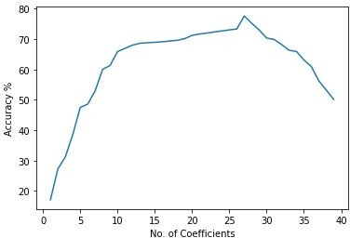

Figure 5.1: Accuracy vs number of features selected

Result for MFCC

Table 5.13: Recognition of result with MFCC (27) features
 | Number of correctly recognized bird sound in the class |  |  |  |  |  |  |  |  |  | RSA
 | RB | GT | WW | EF | CB | CR | GW | BJ | CS | WD
RB | 56 | 0 | 5 | 0 | 0 | 0 | 0 | 8 | 1 | 1 | 85
GT | 0 | 61 | 0 | 2 | 3 | 2 | 1 | 0 | 1 | 1 | 74
WW | 3 | 2 | 59 | 10 | 1 | 2 | 3 | 2 | 2 | 1 | 69
EF | 0 | 21 | 21 | 30 | 2 | 2 | 0 | 0 | 0 | 0 | 45
CB | 0 | 1 | 0 | 5 | 70 | 1 | 1 | 2 | 7 | 0 | 79
CR | 0 | 3 | 0 | 1 | 0 | 43 | 0 | 1 | 0 | 1 | 81
GW | 0 | 0 | 1 | 5 | 4 | 0 | 61 | 1 | 0 | 0 | 87
BJ | 0 | 1 | 1 | 0 | 1 | 5 | 2 | 59 | 10 | 0 | 73
CS | 1 | 4 | 0 | 1 | 9 | 0 | 0 | 6 | 44 | 0 | 65
WD | 0 | 1 | 0 | 2 | 0 | 2 | 0 | 4 | 4 | 38 | 80
Rel. | 93 | 65 | 68 | 54 | 78 | 75 | 90 | 71 | 64 | 86
Overall Accuracy: 73.58%

Table 5.14: Recognition of result with MFCC (27) features with KNN algorithm
 | Number of correctly recognized bird sound in the class |  |  |  |  |  |  |  |  |  | RSA
 | RB | GT | WW | EF | CB | CR | GW | BJ | CS | WD
RB | 72 | 1 | 0 | 0 | 0 | 0 | 0 | 2 | 0 | 1 | 96
GT | 0 | 65 | 0 | 4 | 0 | 0 | 1 | 0 | 0 | 0 | 98
WW | 0 | 0 | 61 | 12 | 0 | 1 | 0 | 0 | 0 | 0 | 82
EF | 0 | 1 | 8 | 72 | 1 | 0 | 0 | 0 | 0 | 0 | 88
CB | 0 | 0 | 0 | 7 | 77 | 1 | 1 | 0 | 0 | 0 | 90
CR | 0 | 0 | 0 | 0 | 0 | 59 | 0 | 0 | 0 | 0 | 100
GW | 0 | 0 | 0 | 0 | 0 | 0 | 69 | 1 | 0 | 0 | 100
BJ | 0 | 0 | 0 | 0 | 0 | 0 | 3 | 75 | 0 | 0 | 100
CS | 0 | 0 | 0 | 0 | 0 | 0 | 0 | 0 | 67 | 0 | 100
WD | 0 | 0 | 0 | 0 | 0 | 0 | 0 | 1 | 0 | 54 | 98
Rel. | 100 | 98 | 88 | 79 | 99 | 97 | 97 | 96 | 100 | 98
Overall Accuracy: 94.70%

Result of LFCC

Table 5.15: Recognition of result with LFCC (27) features
 | Number of correctly recognized bird sound in the class |  |  |  |  |  |  |  |  |  | RSA
 | RB | GT | WW | EF | CB | CR | GW | BJ | CS | WD
RB | 49 | 0 | 5 | 0 | 1 | 5 | 1 | 7 | 3 | 0 | 69
GT | 0 | 57 | 5 | 5 | 1 | 0 | 1 | 1 | 0 | 1 | 80
WW | 1 | 3 | 55 | 12 | 0 | 2 | 5 | 2 | 4 | 1 | 65
EF | 0 | 1 | 18 | 35 | 5 | 1 | 0 | 4 | 0 | 0 | 46
CB | 0 | 3 | 0 | 7 | 65 | 1 | 0 | 0 | 0 | 0 | 75
CR | 0 | 1 | 0 | 0 | 0 | 55 | 0 | 0 | 0 | 0 | 80
GW | 1 | 1 | 2 | 0 | 0 | 0 | 63 | 2 | 0 | 0 | 93
BJ | 0 | 0 | 0 | 0 | 0 | 0 | 3 | 54 | 1 | 0 | 80
CS | 2 | 0 | 0 | 0 | 0 | 0 | 0 | 0 | 54 | 0 | 91
WD | 2 | 1 | 0 | 1 | 2 | 0 | 0 | 5 | 4 | 36 | 71
Rel. | 88 | 71 | 61 | 57 | 89 | 75 | 85 | 69 | 68 | 77
Overall Accuracy: 87.56%

Table 5.16: Recognition of result with LFCC (27) features with KNN algorithm
 | Number of correctly recognized bird sound in the class |  |  |  |  |  |  |  |  |  | RSA
 | RB | GT | WW | EF | CB | CR | GW | BJ | CS | WD
RB | 66 | 1 | 0 | 0 | 0 | 0 | 0 | 0 | 0 | 0 | 99
GT | 3 | 71 | 1 | 5 | 0 | 0 | 0 | 0 | 0 | 0 | 92
WW | 0 | 0 | 58 | 13 | 0 | 1 | 0 | 0 | 0 | 0 | 79
EF | 0 | 2 | 0 | 90 | 6 | 4 | 0 | 4 | 0 | 0 | 93
CB | 0 | 0 | 0 | 5 | 72 | 0 | 0 | 0 | 0 | 0 | 97
CR | 0 | 2 | 0 | 0 | 0 | 54 | 0 | 0 | 0 | 0 | 100
GW | 0 | 2 | 0 | 0 | 0 | 0 | 54 | 0 | 0 | 0 | 96
BJ | 0 | 0 | 0 | 0 | 0 | 0 | 0 | 78 | 1 | 0 | 99
CS | 0 | 0 | 0 | 0 | 0 | 0 | 1 | 0 | 67 | 0 | 99
WD | 0 | 0 | 0 | 0 | 0 | 0 | 0 | 0 | 0 | 63 | 100
Rel. | 95 | 93 | 98 | 82 | 94 | 98 | 98 | 99 | 99 | 100
Overall Accuracy: 95.05%

Result of GFCC

Table 5.17: Recognition of result with GFCC (27) features
 | Number of correctly recognized bird sound in the class |  |  |  |  |  |  |  |  |  | RSA
 | RB | GT | WW | EF | CB | CR | GW | BJ | CS | WD
RB | 49 | 0 | 6 | 2 | 0 | 1 | 0 | 7 | 7 | 0 | 69
GT | 0 | 48 | 3 | 7 | 7 | 0 | 0 | 0 | 0 | 6 | 68
WW | 19 | 4 | 42 | 5 | 1 | 3 | 6 | 5 | 0 | 0 | 49
EF | 0 | 5 | 24 | 41 | 2 | 0 | 0 | 0 | 0 | 0 | 54
CB | 1 | 1 | 0 | 3 | 82 | 1 | 2 | 0 | 0 | 0 | 70
CR | 1 | 0 | 5 | 3 | 0 | 30 | 0 | 3 | 0 | 7 | 61
GW | 0 | 0 | 0 | 0 | 0 | 0 | 70 | 1 | 0 | 0 | 97
BJ | 3 | 0 | 0 | 0 | 2 | 2 | 2 | 64 | 6 | 1 | 81
CS | 8 | 0 | 2 | 3 | 4 | 0 | 0 | 7 | 43 | 0 | 64
WD | 0 | 5 | 3 | 1 | 3 | 1 | 4 | 4 | 0 | 30 | 59
Rel. | 60 | 76 | 49 | 62 | 77 | 83 | 69 | 71 | 69 | 68
Overall Accuracy: 85.22%

Table 5.18: Recognition of result with GFCC (27) features with KNN algorithm
 | Number of correctly recognized bird sound in the class |  |  |  |  |  |  |  |  |  | RSA
 | RB | GT | WW | EF | CB | CR | GW | BJ | CS | WD
RB | 62 | 0 | 0 | 0 | 0 | 0 | 0 | 0 | 0 | 0 | 100
GT | 0 | 69 | 2 | 3 | 0 | 0 | 0 | 0 | 0 | 0 | 93
WW | 0 | 2 | 57 | 10 | 0 | 1 | 0 | 0 | 0 | 0 | 83
EF | 0 | 0 | 6 | 65 | 3 | 0 | 0 | 0 | 0 | 0 | 88
CB | 1 | 0 | 0 | 5 | 87 | 0 | 2 | 0 | 0 | 0 | 94
CR | 0 | 0 | 0 | 0 | 0 | 55 | 1 | 0 | 0 | 1 | 92
GW | 0 | 0 | 0 | 0 | 0 | 0 | 61 | 0 | 0 | 0 | 98
BJ | 0 | 0 | 0 | 0 | 0 | 0 | 3 | 73 | 1 | 0 | 94
CS | 0 | 0 | 0 | 0 | 0 | 0 | 0 | 0 | 71 | 0 | 100
WD | 1 | 3 | 7 | 3 | 0 | 2 | 0 | 0 | 0 | 49 | 75
Rel. | 95 | 93 | 78 | 76 | 97 | 96 | 94 | 100 | 99 | 92
Overall Accuracy: 91.66%

Table 5.19: Overall Accuracy of Feature Selection
Sr. No. | Feature set | KNN | SVM
1 | MFCC | 94.7 | 73.58
2 | LFCC | 95.05 | 87.56
3 | GFCC | 91.66 | 85.22

Table 5.18 shows the overall accuracy of the feature selection technique with SVM and the KNN algorithm. LFCC with KNN algorithm gives an accuracy of 95.05
% From the above result, It is observed that European Pied Flycatcher(EF) gives bad results. Common Blackbird(CB) gives the best result in the Feature selection technique.

Classification
For classification, K-Nearest Neighbors (KNN) algorithm, Artificial Neural Network (ANN) algorithm and Convolutional Neural Network (CNN) algorithm are used.

Classification using KNN 5.7.1.1Result of MFCC

Table 5.20: Recognition of result with MFCC (13) features with KNN algorithm
 | Number of correctly recognized bird sound |  |  |  |  |  |  |  |  |  | RSA
 | RB | GT | WW | EF | CB | CR | GW | BJ | CS | WD
RB | 69 | 0 | 0 | 0 | 1 | 0 | 0 | 0 | 2 | 0 | 97
GT | 0 | 66 | 1 | 8 | 0 | 0 | 0 | 0 | 0 | 3 | 91
WW | 0 | 1 | 72 | 5 | 0 | 0 | 0 | 0 | 0 | 0 | 90
EF | 0 | 0 | 9 | 68 | 0 | 0 | 0 | 0 | 0 | 0 | 84
CB | 1 | 0 | 0 | 2 | 68 | 0 | 1 | 0 | 0 | 0 | 95
CR | 0 | 0 | 0 | 2 | 0 | 54 | 1 | 0 | 0 | 1 | 96
GW | 0 | 0 | 0 | 0 | 0 | 0 | 54 | 2 | 0 | 0 | 96
BJ | 0 | 0 | 0 | 0 | 0 | 0 | 0 | 79 | 1 | 0 | 96
CS | 0 | 0 | 0 | 0 | 2 | 0 | 0 | 0 | 74 | 0 | 97
WD | 0 | 0 | 0 | 0 | 0 | 0 | 0 | 0 | 0 | 58 | 94
Rel. | 99 | 99 | 88 | 80 | 96 | 100 | 96 | 94 | 96 | 94
Overall Accuracy: 91.13%

Table 5.21: Recognition of result with MFCC (26) features with KNN algorithm
 | Number of correctly recognized bird sound |  |  |  |  |  |  |  |  |  | RSA
 | RB | GT | WW | EF | CB | CR | GW | BJ | CS | WD
RB | 62 | 1 | 0 | 0 | 0 | 0 | 0 | 0 | 0 | 0 | 99
GT | 0 | 81 | 1 | 4 | 0 | 0 | 0 | 0 | 0 | 0 | 96
WW | 0 | 1 | 61 | 11 | 0 | 0 | 0 | 0 | 0 | 0 | 84
EF | 0 | 0 | 11 | 66 | 2 | 0 | 0 | 0 | 0 | 0 | 79
CB | 0 | 0 | 0 | 6 | 71 | 1 | 1 | 0 | 1 | 0 | 93
CR | 0 | 0 | 0 | 0 | 0 | 55 | 1 | 0 | 0 | 0 | 98
GW | 0 | 0 | 0 | 0 | 0 | 0 | 69 | 0 | 0 | 0 | 98
BJ | 0 | 0 | 0 | 0 | 0 | 0 | 1 | 80 | 2 | 0 | 98
CS | 0 | 0 | 0 | 0 | 0 | 0 | 0 | 0 | 63 | 0 | 98
WD | 0 | 0 | 0 | 0 | 1 | 0 | 0 | 1 | 0 | 54
Rel. | 100 | 98 | 84 | 75 | 97 | 98 | 96 | 99 | 95 | 1
Overall Accuracy: 91.50%

Table 5.22: Recognition of result with MFCC (39) features with KNN algorithm
 | Number of correctly recognized bird sound |  |  |  |  |  |  |  |  |  | RSA
 | RB | GT | WW | EF | CB | CR | GW | BJ | CS | WD
RB | 68 | 2 | 0 | 0 | 5 | 0 | 0 | 1 | 0 | 0 | 94
GT | 0 | 57 | 0 | 5 | 0 | 0 | 0 | 0 | 0 | 0 | 92
WW | 0 | 1 | 65 | 12 | 0 | 0 | 0 | 0 | 0 | 0 | 87
EF | 0 | 1 | 6 | 77 | 2 | 0 | 3 | 0 | 0 | 0 | 84
CB | 0 | 0 | 0 | 1 | 72 | 0 | 1 | 0 | 0 | 0 | 94
CR | 0 | 0 | 0 | 0 | 0 | 48 | 0 | 0 | 0 | 0 | 100
GW | 0 | 0 | 0 | 0 | 0 | 0 | 60 | 1 | 0 | 0 | 96
BJ | 0 | 1 | 1 | 0 | 0 | 0 | 0 | 85 | 0 | 0 | 97
CS | 0 | 0 | 0 | 0 | 0 | 0 | 0 | 0 | 74 | 0 | 100
WD | 1 | 0 | 0 | 0 | 0 | 0 | 0 | 1 | 0 | 57 | 98
Rel. | 99 | 92 | 90 | 81 | 91 | 100 | 94 | 97 | 100 | 100
Overall Accuracy: 93.64%

Result of LFCC

Table 5.23: Recognition of result with LFCC (13) features with KNN algorithm
 | Number of correctly recognized bird sound |  |  |  |  |  |  |  |  |  | RSA
 | RB | GT | WW | EF | CB | CR | GW | BJ | CS | WD
RB | 69 | 1 | 0 | 0 | 0 | 0 | 0 | 0 | 0 | 0 | 97
GT | 3 | 65 | 1 | 0 | 0 | 0 | 0 | 0 | 0 | 0 | 91
WW | 0 | 3 | 61 | 8 | 0 | 1 | 0 | 2 | 0 | 0 | 85
EF | 0 | 0 | 5 | 61 | 6 | 4 | 0 | 4 | 0 | 0 | 79
CB | 0 | 3 | 0 | 5 | 83 | 1 | 0 | 0 | 0 | 0 | 92
CR | 0 | 1 | 0 | 0 | 0 | 55 | 0 | 0 | 0 | 0 | 94
GW | 1 | 1 | 2 | 0 | 0 | 0 | 55 | 2 | 0 | 0 | 92
BJ | 0 | 0 | 0 | 0 | 0 | 0 | 3 | 86 | 1 | 0 | 93
CS | 0 | 0 | 0 | 0 | 0 | 0 | 0 | 0 | 63 | 0 | 99
WD | 0 | 0 | 0 | 0 | 0 | 0 | 0 | 0 | 0 | 52 | 100
Rel. | 95 | 88 | 88 | 82 | 93 | 90 | 95 | 91 | 98 | 100
Overall Accuracy: 91.80%

Table 5.24: Recognition of result with LFCC (26) features with KNN algorithm
 | Number of correctly recognized bird sound |  |  |  |  |  |  |  |  |  | RSA
 | RB | GT | WW | EF | CB | CR | GW | BJ | CS | WD
RB | 69 | 2 | 0 | 0 | 0 | 0 | 0 | 0 | 0 | 0 | 96
GT | 0 | 67 | 0 | 0 | 0 | 0 | 0 | 0 | 0 | 0 | 95
WW | 0 | 1 | 67 | 7 | 0 | 0 | 0 | 2 | 0 | 0 | 85
EF | 0 | 1 | 13 | 70 | 2 | 0 | 0 | 0 | 0 | 0 | 82
CB | 1 | 0 | 0 | 6 | 73 | 0 | 0 | 0 | 1 | 0 | 94
CR | 0 | 2 | 0 | 0 | 0 | 61 | 0 | 0 | 0 | 0 | 98
GW | 0 | 0 | 0 | 0 | 0 | 0 | 60 | 2 | 0 | 0 | 96
BJ | 0 | 0 | 0 | 0 | 0 | 0 | 3 | 78 | 0 | 0 | 96
CS | 3 | 1 | 0 | 0 | 0 | 0 | 0 | 0 | 57 | 1 | 95
WD | 0 | 0 | 0 | 1 | 0 | 0 | 0 | 0 | 0 | 57 | 98
Rel. | 95 | 91 | 84 | 83 | 97 | 100 | 95 | 95 | 98 | 98
Overall Accuracy: 91.76%

Table 5.25: Recognition of result with LFCC (39) features with KNN algorithm
 | Number of correctly recognized bird sound |  |  |  |  |  |  |  |  |  | RSA
 | RB | GT | WW | EF | CB | CR | GW | BJ | CS | WD
RB | 77 | 0 | 0 | 0 | 0 | 0 | 0 | 0 | 1 | 0 | 99
GT | 0 | 63 | 1 | 0 | 0 | 0 | 0 | 0 | 0 | 0 | 98
WW | 0 | 1 | 66 | 12 | 0 | 0 | 0 | 0 | 0 | 1 | 85
EF | 0 | 1 | 4 | 70 | 3 | 0 | 0 | 0 | 0 | 0 | 85
CB | 0 | 0 | 0 | 2 | 81 | 2 | 3 | 0 | 0 | 0 | 94
CR | 0 | 0 | 2 | 2 | 0 | 49 | 0 | 0 | 0 | 0 | 94
GW | 0 | 0 | 2 | 0 | 0 | 0 | 63 | 0 | 0 | 0 | 96
BJ | 0 | 0 | 0 | 0 | 0 | 0 | 0 | 78 | 0 | 0 | 100
CS | 1 | 0 | 0 | 0 | 0 | 0 | 0 | 0 | 69 | 2 | 97
WD | 0 | 0 | 0 | 1 | 0 | 0 | 0 | 0 | 0 | 51 | 96
Rel. | 99 | 97 | 88 | 80 | 96 | 96 | 95 | 100 | 99 | 94
Overall Accuracy: 91.90%

Result of GFCC

Table 5.26: Recognition of result with GFCC (13) features with KNN algorithm
 | Number of correctly recognized bird sound |  |  |  |  |  |  |  |  |  | RSA
 | RB | GT | WW | EF | CB | CR | GW | BJ | CS | WD
RB | 65 | 0 | 0 | 0 | 0 | 1 | 0 | 2 | 2 | 0 | 95
GT | 0 | 72 | 0 | 0 | 0 | 0 | 0 | 1 | 0 | 0 | 99
WW | 0 | 1 | 70 | 13 | 0 | 1 | 0 | 0 | 0 | 0 | 88
EF | 0 | 0 | 4 | 55 | 2 | 0 | 0 | 0 | 0 | 0 | 83
CB | 1 | 0 | 0 | 4 | 82 | 1 | 2 | 0 | 0 | 0 | 94
CR | 0 | 0 | 0 | 0 | 0 | 54 | 0 | 1 | 0 | 1 | 96
GW | 0 | 0 | 0 | 0 | 0 | 0 | 66 | 1 | 0 | 0 | 97
BJ | 0 | 0 | 0 | 0 | 0 | 0 | 1 | 80 | 1 | 1 | 94
CS | 0 | 0 | 0 | 0 | 0 | 0 | 0 | 4 | 75 | 0 | 96
WD | 1 | 0 | 0 | 0 | 0 | 0 | 0 | 0 | 0 | 44 | 97
Rel. | 97 | 99 | 95 | 76 | 98 | 95 | 96 | 91 | 96 | 96
Overall Accuracy: 91.64%

Table 5.27: Recognition of result with GFCC (26) features with KNN algorithm
 | Number of correctly recognized bird sound |  |  |  |  |  |  |  |  |  | RSA
 | RB | GT | WW | EF | CB | CR | GW | BJ | CS | WD
RB | 71 | 1 | 1 | 0 | 0 | 0 | 0 | 0 | 1 | 0 | 96
GT | 0 | 72 | 1 | 0 | 0 | 0 | 0 | 0 | 0 | 0 | 97
WW | 2 | 1 | 69 | 20 | 0 | 0 | 0 | 4 | 0 | 1 | 78
EF | 0 | 2 | 7 | 72 | 5 | 0 | 0 | 0 | 0 | 0 | 79
CB | 0 | 0 | 0 | 4 | 72 | 0 | 1 | 0 | 0 | 0 | 94
CR | 0 | 0 | 0 | 0 | 0 | 45 | 0 | 0 | 0 | 0 | 100
GW | 0 | 0 | 0 | 0 | 0 | 0 | 65 | 1 | 0 | 0 | 98
BJ | 0 | 0 | 2 | 0 | 0 | 0 | 0 | 74 | 1 | 0 | 95
CS | 0 | 0 | 0 | 0 | 0 | 0 | 0 | 0 | 70 | 0 | 99
WD | 1 | 0 | 0 | 0 | 0 | 0 | 0 | 0 | 0 | 42 | 98
Rel. | 96 | 95 | 86 | 75 | 94 | 100 | 98 | 94 | 97 | 98
Overall Accuracy: 92.32%

Table 5.28: Recognition of result with GFCC (39) features with KNN algorithm
 | Number of correctly recognized bird sound |  |  |  |  |  |  |  |  |  | RSA
 | RB | GT | WW | EF | CB | CR | GW | BJ | CS | WD
RB | 64 | 0 | 0 | 0 | 0 | 0 | 0 | 0 | 1 | 0 | 98
GT | 0 | 71 | 0 | 2 | 0 | 2 | 0 | 0 | 0 | 0 | 95
WW | 0 | 2 | 63 | 12 | 0 | 0 | 0 | 0 | 0 | 0 | 85
EF | 0 | 1 | 4 | 81 | 3 | 0 | 0 | 0 | 0 | 0 | 86
CB | 1 | 0 | 0 | 3 | 77 | 1 | 0 | 0 | 0 | 0 | 95
CR | 0 | 0 | 0 | 0 | 0 | 60 | 0 | 0 | 0 | 1 | 97
GW | 0 | 0 | 0 | 0 | 0 | 0 | 56 | 1 | 0 | 0 | 99
BJ | 0 | 0 | 5 | 0 | 0 | 0 | 0 | 71 | 2 | 0 | 95
CS | 0 | 0 | 0 | 0 | 0 | 0 | 0 | 0 | 75 | 0 | 98
WD | 1 | 0 | 0 | 2 | 0 | 0 | 0 | 0 | 0 | 46 | 96
Rel. | 97 | 96 | 88 | 81 | 96 | 95 | 100 | 99 | 96 | 98
Overall Accuracy: 91.61%

Table 5.29: Overall Accuracy of Feature Extraction using KNN algorithm
Sr No. | Feature vector | MFCC | LFCC | GFCC
1 | 13 coefficients | 91.13 | 91.8 | 91.64
2 | 26 coefficients | 91.5 | 91.76 | 92.32
3 | 39 coefficients | 93.64 | 91.9 | 91.61

Table 5.28 shows the Overall accuracy of Feature Extraction using the KNN algorithm. MFCC with 39 coefficients gives the highest accuracy of 93.64 %. From the above result, it is observed that Willow Warbler(WW) and European Pied Fly- catcher(EF) gives bad results. Common Blackbird(CB) gives the best result in the Feature extraction technique.

Classification using ANN
In the classification using the ANN algorithm, The graph shows Training and Vali- dation accuracy and loss of MFCC, LFCC and GFCC features. I observed that at 20 epoch training accuracy achieved maximum accuracy.

Result of MFCC

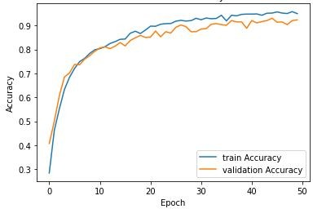
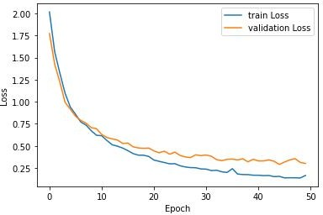
        - (b)
Figure 5.2: Training and Validation Accuracy and loss of 13 MFCC coefficients

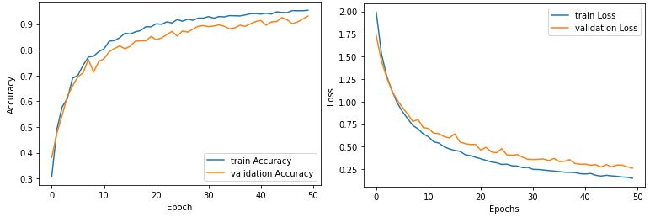
(a) (b)
Figure 5.3: Training and Validation Accuracy and loss of 26 MFCC coefficients

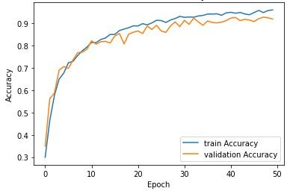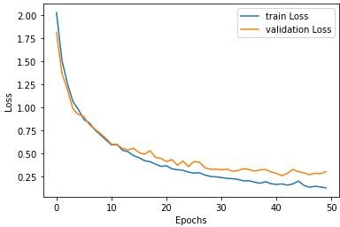
(a) (b)
Figure 5.4: Training and Validation Accuracy and loss of 39 MFCC coefficients

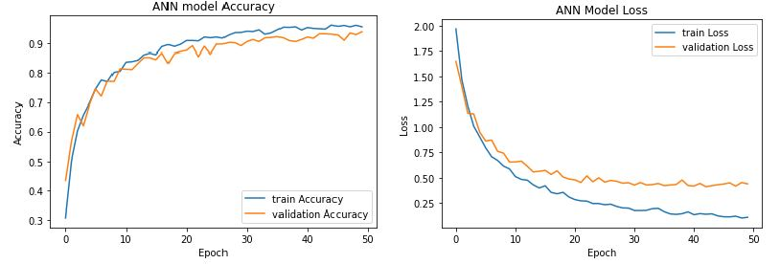
(a) (b)
Figure 5.5: Training and Validation Accuracy and loss of 27 MFCC coefficients

Result of LFCC

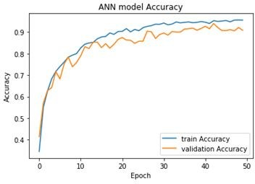
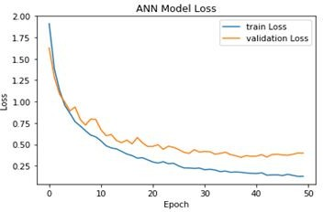
        - (b)
Figure 5.6: Training and Validation Accuracy and loss of 13 LFCC coefficients

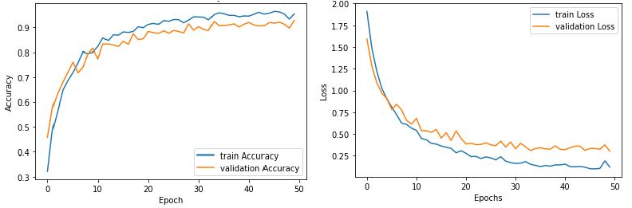
(a) (b)
Figure 5.7: Training and Validation Accuracy and loss of 26 LFCC coefficients

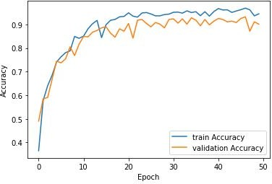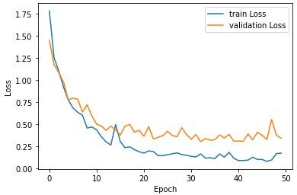
(a) (b)
Figure 5.8: Training and Validation Accuracy and loss of 39 LFCC coefficients

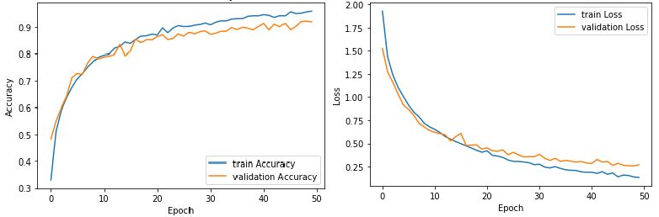
(a) (b)
Figure 5.9: Training and Validation Accuracy and loss of 27 LFCC coefficients

Result of GFCC

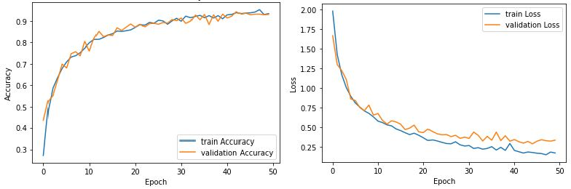
        - (b)
Figure 5.10: Training and Validation Accuracy and loss of 13 GFCC coefficients

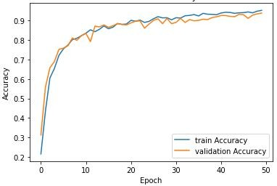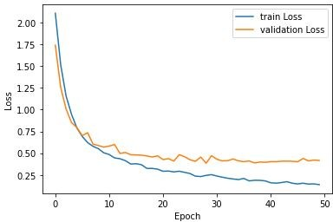
(a) (b)
Figure 5.11: Training and Validation Accuracy and loss of 26 GFCC coefficients

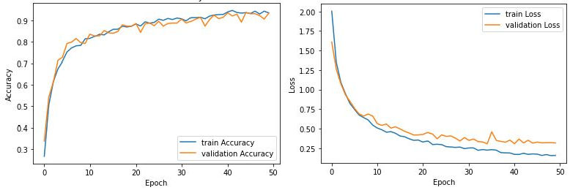
(a) (b)
Figure 5.12: Training and Validation Accuracy and loss of 39 GFCC coefficients

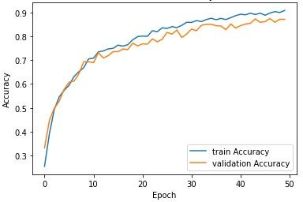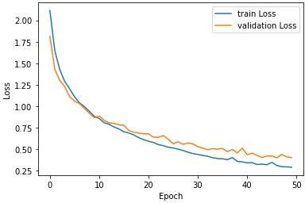
(a) (b)
Figure 5.13: Training and Validation Accuracy and loss of 27 GFCC coefficients

Table 5.30: Overall Accuracy of Feature Extraction using ANN algorithm
Sr No. | Feature vector | MFCC | LFCC | GFCC
1 | 13 coefficients | 91.6 | 92.03 | 92.67
2 | 26 coefficients | 92.07 | 91.66 | 92.87
3 | 39 coefficients | 91.94 | 91.88 | 92.33
4 | 27 coefficients | 94.7 | 92.6 | 87.88

Table 5.29 shows the overall accuracy of Feature extraction using ANN. MFCC with 27 coefficients gives maximum accuracy of 94.70 %. Figure 5.1,5.2,5.3 and 5.4 shows the Training and validation accuracy of MFCC coefficients. Figure 5.5,5.6,5.7 and
  - shows Training and validation accuracy of LFCC coefficients. Figure 5.9,5.10,5.11 and 5.12 shows the Training and validation accuracy of GFCC coefficients.

Classification using CNN Algorithm
In the classification using the CNN algorithm, The graph shows Training and Vali- dation accuracy and loss of MFCC, LFCC and GFCC features. I observed that at 10 epoch training accuracy achieved maximum accuracy.

Result of MFCC

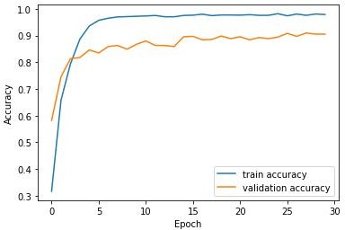
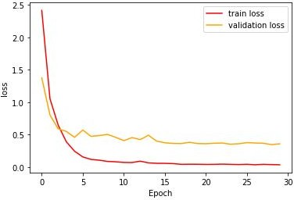

        - (b)
Figure 5.14: Training and Validation Accuracy and loss of 13 MFCC coefficients

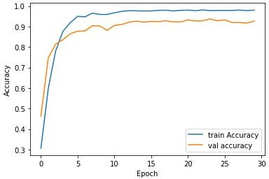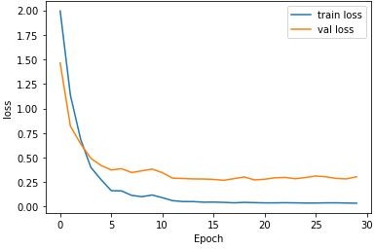
(a) (b)
Figure 5.15: Training and Validation Accuracy and loss of 26 MFCC coefficients

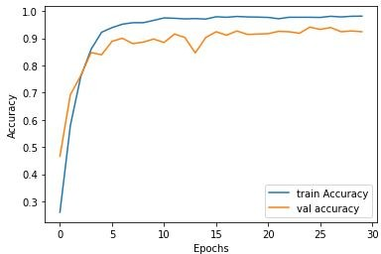
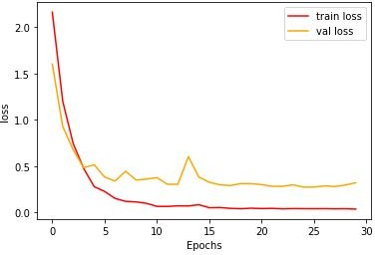
(a) (b)
Figure 5.16: Training and Validation Accuracy and loss of 39 MFCC coefficients
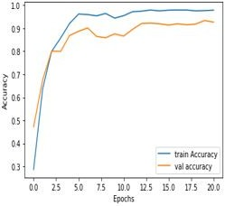
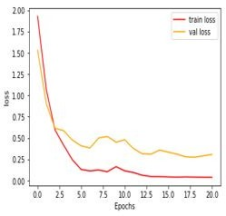
(a) (b)
Figure 5.17: Training and Validation Accuracy and loss of 27 MFCC coefficients

Result of LFCC

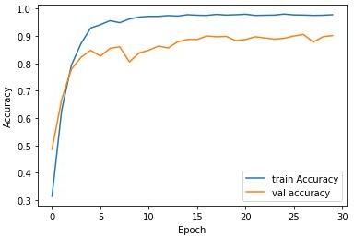
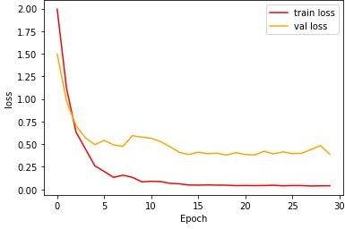
        - (b)
Figure 5.18: Training and Validation Accuracy and loss of 13 LFCC coefficients

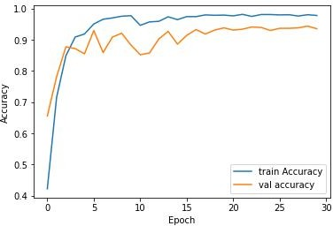
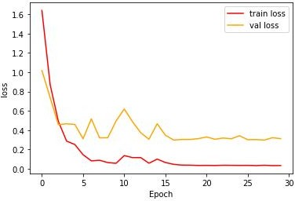
(a) (b)
Figure 5.19: Training and Validation Accuracy and loss of 26 LFCC coefficients

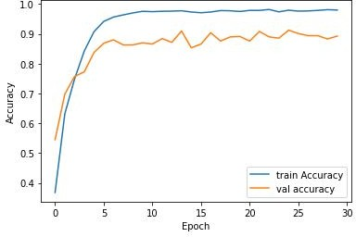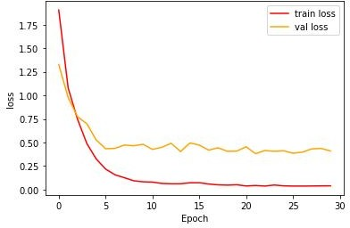
(a) (b)
Figure 5.20: Training and Validation Accuracy and loss of 39 LFCC coefficients

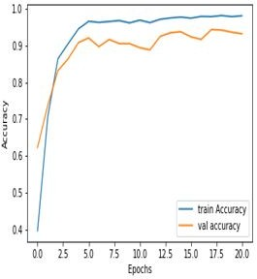
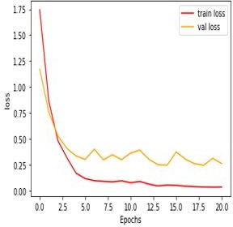
(a) (b)
Figure 5.21: Training and Validation Accuracy and loss of 27 LFCC coefficients

Result of GFCC

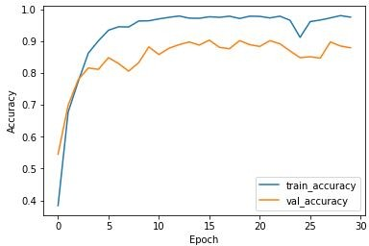
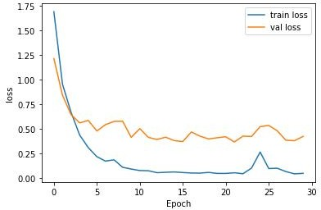
        - (b)
Figure 5.22: Training and Validation Accuracy and loss of 13 GFCC coefficients

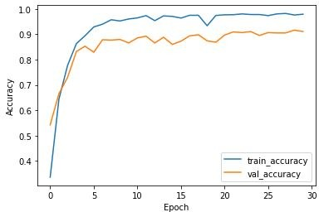
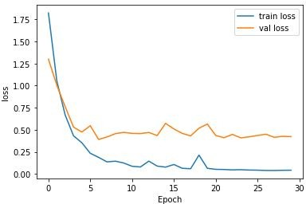
(a) (b)
Figure 5.23: Training and Validation Accuracy and loss of 26 GFCC coefficients

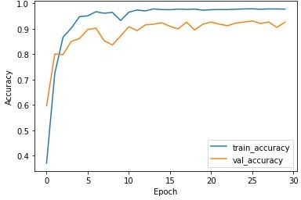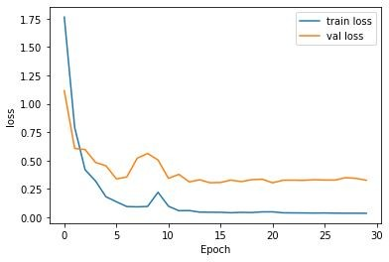
(a) (b)
Figure 5.24: Training and Validation Accuracy and loss of 39 GFCC coefficients

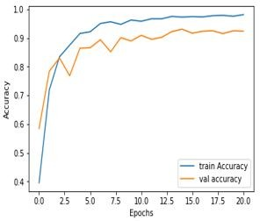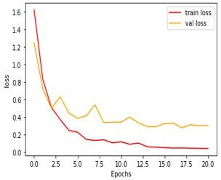
(a) (b)
Figure 5.25: Training and Validation Accuracy and loss of 27 GFCC coefficients

Table 5.31: Overall Accuracy of Feature Extraction using CNN algorithm
Sr No. | Feature vector | MFCC | LFCC | GFCC
1 | 13 coefficients | 91.6 | 92.03 | 92.67
2 | 26 coefficients | 92.07 | 91.66 | 92.87
3 | 39 coefficients | 91.94 | 91.88 | 92.33
4 | 27 coefficients | 94.7 | 92.6 | 87.88

Table 5.30 shows the Overall accuracy of Feature Extraction using the CNN algorithm.MFCC with 27 coefficients achieved maximum accuracy of 94.70 %
Table 5.32: Classification accuracy of Different Feature set and classifiers
Sr.No | Feature Set | Length of Feature Vector | Accuracy
 |  |  | KNN | SVM | ANN | CNN
1 | Mel Frequency Cepstral Coefficients | 13 | 91.13% | 82.38% | 91.60% | 91.13%
 |  | 26 | 91.50% | 81.33% | 92.07% | 90.36%
 |  | 39 | 93.64% | 82.21% | 91.94% | 92.70%
 |  | 27 | 94.70% | 73.58% | 94.70% | 93.60%
2 | Linear Frequency Cepstral Coefficients | 13 | 91.80% | 85.53% | 92.03% | 91.67%
 |  | 26 | 91.76% | 85.49% | 91.66% | 90.67%
 |  | 39 | 91.90% | 85.88% | 91.88% | 92.80%
 |  | 27 | 95.05% | 87.56% | 92.60% | 93.80%
3 | Gammatone Frequency Cepstral coefficients | 13 | 91.64% | 87.64% | 92.67% | 91.58%
 |  | 26 | 92.32% | 87.44% | 92.87% | 91.18%
 |  | 39 | 91.61% | 85.88% | 92.33% | 90.18%
 |  | 27 | 91.66% | 85.22% | 87.88% | 93.44%

Table 5.31 shows the summary of classification accuracy of different feature sets and classifiers.

5.8Summary
The database of bird sounds was used for the classification of birds. The effect of features with various classifiers was explored in the chapter. It is observed that CNN gives the best result compared to other classifiers. The MFCCs outperform as features compared to LFCC and GFCC. The feature selection further improves the accuracy of classification.

Chapter 6 Conclusion and Future Scope
Three sets of classifiers and feature sets are selected to classify bird species. The
testing accuracy of all feature set is evaluated. Gammatone Frequency Cepstral Coefficients with feature selection technique gives an accuracy of 93.44 %. Linear Frequency Cepstral Coefficients with feature selection techniques offers maximum accuracy of 95.05 %. The performance of the system is evaluated for different classifiers. The Recursive Feature Elimination (RFE) algorithm further improves the accuracy. CNN with MFCC as features gives the highest accuracy compared to LFCC and GFCC. Future work can be done by considering more feature selection methods with a different algorithm. Also, combining selected features with another algorithm will increase accuracy.

Bibliography

[1]A. Charisma, M.R. Hidayat and Y.B. Zainal (2017). Speaker recognition using mel-frequency cepstrum coefficients and sum square error (3rd International Conference on Wireless and Telematics (ICWT), 2017),pp. 160-163.
[2]J. Xie, K. Hu, M. Zhu, J. Yu and Q. Zhu (2019). Investigation of Different CNN-Based Models for Improved Bird Sound Classification, vol. 7, pp. 175353- 175361
[3] A´. Incze, H. Jancs´o, Z. Szil´agyi, A. Farkas and C. Sulyok,(2018). Bird sound recognition using a convolutional neural network,Proc. IEEE 16th Int. Symp. Intell. Syst. Inform. (SISY), pp. 000295-000300,

[4]P. Jancovic, M. K fi ok¨ uer, M. Zakeri, and M. Russell, (2016). Bird species recog- ¨ nition using HMM-based unsupervised modelling of individual syllables with incorporated duration modelling, in International Conference on Acoustics, Speech and Signal Processing (ICASSP,pp. 559–563.
- Lee, Chang-Hsing & Lee, Yeuan-kuen & Huang, Ren-zhuang.(2006). Automatic Recognition of Bird Songs Using Cepstral Coefficients.Journal of Information Technology and Applications Vol. 1 No. 1,May, 2006, pp.17-23
- Patole R., Rege P. (2021). Acoustic Classification of Bird Species. Advances in Signal and Data Processing. Lecture Notes in Electrical Engineering, vol 703. Springer, Singapore.

- Trifa VM, Kirschel AN, Taylor CE, Vallejo EE (2008). species recognition of antbirds in a Mexican rainforest using hidden Markov models. IJ Acoust Soc Am. ;123(4):pp2424-2431.
- Dewi, Sita & Prasasti, Anggunmeka & Irawan, Budhi.(2019) Analysis of LFCC Feature Extraction in Baby Crying Classification using KNN (IEEE Interna- tional Conference on Internet of Things and Intelligence System (IoTaIS),pp. 86-91).
- Jianyu Miao, Lingfeng Niu(2016)„ A Survey on Feature Selection Procedia Computer Science,Volume 91,Pages 919-926.
- S´anchez-Maron˜o N., Alonso-Betanzos A., Tombilla-Sanrom´an M.(2007) Filter Methods for Feature Selection – A Comparative Study ( Intelligent Data Engi- neering and Automated Learning - IDEAL,vol 4881).
- Guyon, I., Weston, J., Barnhill, S. et al..(2002) Gene Selection for Cancer Clas- sification using Support Vector Machines. Machine Learning 46, pp. 389–422
.
- Rassak S, Nachamai M(2016) Survey study on the methods of bird vocaliza- tion classification IEEE international conference on current trends in advanced computing (ICCTAC),pp 1-8.
- Valero X, Alias F(2012) Gammatone cepstral coefficients: Biologically inspired features for non-speech audio classification. IEEE Trans Multimedia 14(6): pp1684–1689.
- Towards Datascience Homepage https://machinelearningmastery.com/feature- selection-with-real-and-categorical-data/
[15]X. Chen and J. C. Jeong(2007) recursive feature elimination. Sixth International Conference on Machine Learning and Applications pp. 429-435.

Bibliography

